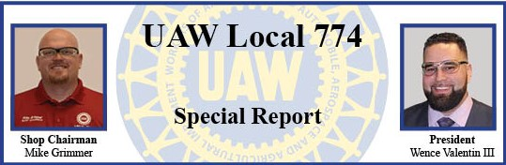
April 12, 2021
Dear Sisters and Brothers:
Due to the surging cases of Covid-19 in the country and in our plant the International has advised us to cancel the April meeting and the Regional training that was to be held at the Hall this month. Our members health is too important to risk.
We will reevaluate the May meeting and will communicate to the membership once we have further details.
Thank you all for your dedication and commitment.

Wence and Mike

