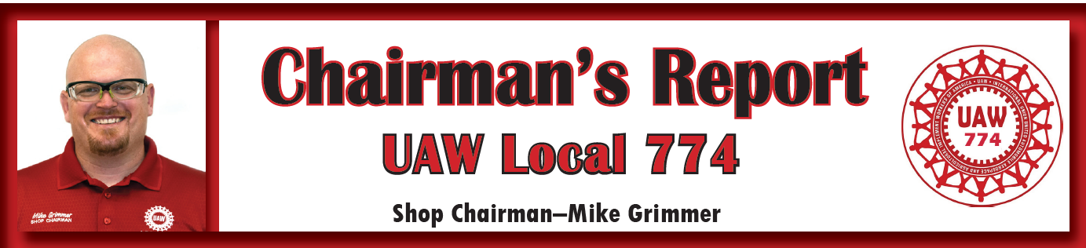
January 7, 2022
Sisters and Brothers,

The Omicron variant of Covid 19 has spread like wildfire in the plant and across the country. As of Friday January 7^{th,} Tonawanda Engine Plant has 74 people out on Covid Leave with 46 positive cases. This is the most people out on Covid leave to date here at the plant since the beginning of this pandemic. We need everyone to be sure to wear their face masks properly to respect and ensure the safety of our coworkers. Regardless of the varying opinions on the issue, the proper wearing of the facemasks is required by General Motors at all time in the plant unless actively eating or drinking. Management informed the Shop Committee that this will be strictly enforced going forward with the spike in positive cases. Please wear your facemasks correctly to avoid being subject to discipline for safety rule infractions related to Covid protocols.
Appendix A Plant Transfer Opportunities - There are currently 250 Appendix A transfer opportunities to Lansing Delta Township Assembly Plant in Michigan and 9 openings at the Marion Stamping Plant in Ohio. With the upcoming buildout of the LGE Engine Program in Plant 5 this fall, anyone interested in transferring to another plant can look at these openings and apply on Socrates by January 13th, 2022. Please call Karen McCoy at 716-879-5071 with any questions about the transfer system.
On Sunday January 9th we will be having our first UAW 774 Union Meeting at 10:00 AM at our Union Hall. Everyone is encouraged to come to get up to date accurate information and ask questions. In Solidarity,
Mike Grimmer

